- List all employees and jobs in Department 30 in descending order by salary.
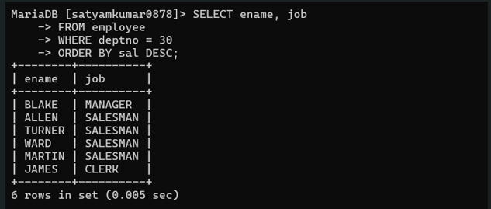
- List job and Department Number of employees whose name are five letters long begin with “A” and end with “N”.
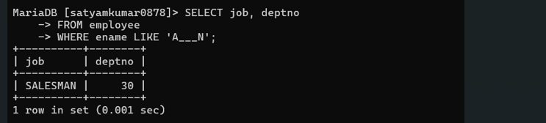
- Display the name of employees whose name start with alphabet S.
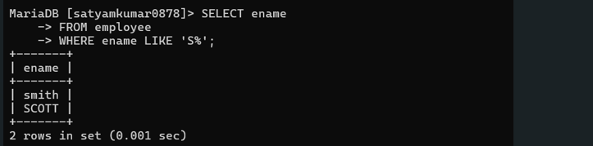
- Display the names of employees whose name ends with alphabet S.
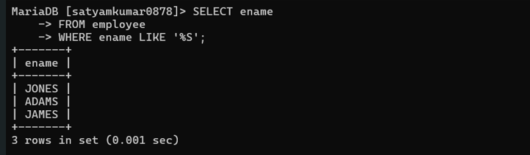
- Display the names of employees working in department number 10 or 20 or 40 or employees working as clerks, salesman or analyst.
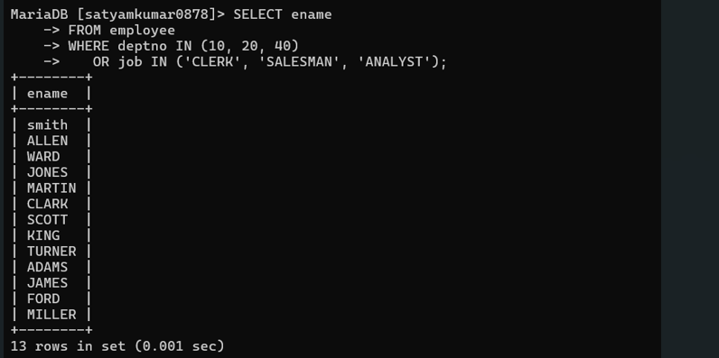
- Display employee number and names for employees who earn commission.
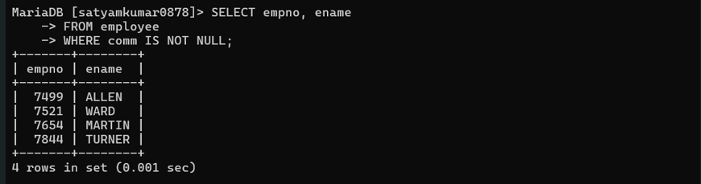
- Display employee number and total salary for each employee.
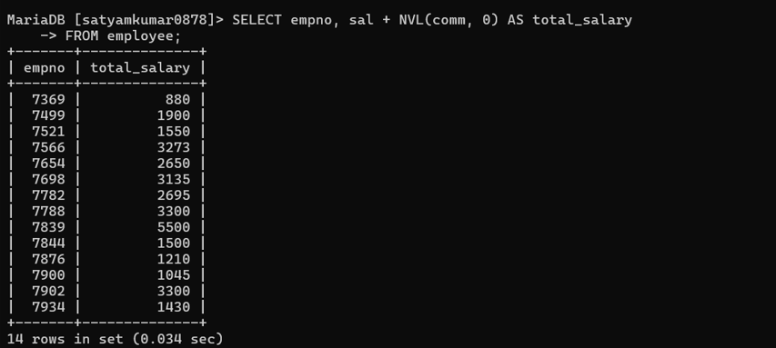
- Display employee number and annual salary for each employee.

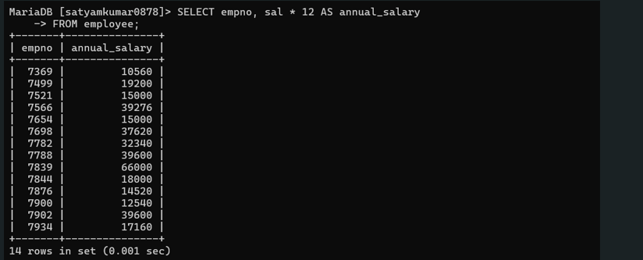
- Display the names of all employees working as clerks and drawing a salary more than 3,000.
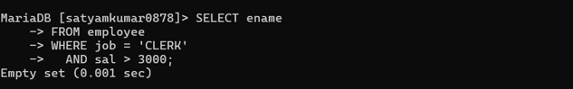
- Display the names of employees who are working as clerk, salesman or analyst and drawing a salary more than 3,000.
